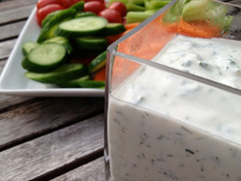

Greek yogurt ranch dip
Ingredients:
- 1 cup (250mL) 0% plain Greek yogurt
- 3 Tbsp (45mL) light mayonnaise
- ½ tsp (2mL) grated lemon skin (little pieces)
- 2 Tbsp (25mL) lemon juice
- 2 Tbsp (25mL) chopped fresh dill
- 1 Tbsp (15mL) each chopped fresh chives or parsley
- 1 clove garlic, minced (into very small pieces)
- 3 Tbsp (45mL) skim milk
Directions:
1. In a bowl, mix yogurt, mayonnaise, lemon skin, lemon juice, dill, chives or parsley, garlic and milk until smooth.
2. Have this with fresh cut vegetables (ex: carrots, cucumber, peppers, broccoli, and cauliflower)

