Maple Chocolate Mug Muffin
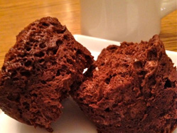

(2 small servings)

Ingredients:
- 1 egg
- 1 Tbsp (15mL) maple syrup
- ½ tsp (2mL) vanilla
- 2 Tbsp (25mL) bran buds (round shape)
- 2 Tbsp (25mL) unsweetened cocoa powder
- ¼ tsp (1mL) baking powder
- small amount of cinnamon (powder) that can be held with two fingers
Directions:
1. Put egg in cup. Mix with fork.
2.Then add maple syrup, vanilla, bran buds, cocoa powder, baking powder, and cinnamon. Mix well.
3. Put the cup in the microwave and cook on high for 1 minute and 45 seconds

