Mini pizzas
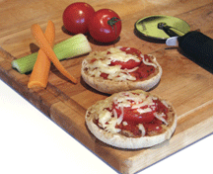
Makes 2 servings.
Quick fix tip - This recipe can be made from leftovers.
Ingredients
- 4 small tomatoes, thinly cut
- 2 whole-grain English muffins, cut in half
- 3/4 cup (175 mL) shredded part-skim mozzarella cheese
- 1/2 cup (125 mL) pizza or tomato sauce
You can also use: Leftover chicken or beef, red peppers, mushrooms, onions or tuna.
Directions
- Preheat your oven to 400ºF (200ºC).
- Toast English muffin in oven until lightly browned (5 minutes).
- Spread approximately 30 mL (2 tbsp) of sauce on each half of the English muffin.
- Cover the sauce with tomato slices and any other vegetable or meat of your choice.
- Put mozzarella cheese on top of tomatoes.
- Put mini pizzas on a baking sheet and bake until cheese is melted (5 minutes).
- Remove from oven and let cool.
- Serve
Tip: Can be sent in container for lunches. Send with celery and carrot sticks.

