One-pot Tuna and Broccoli Pasta
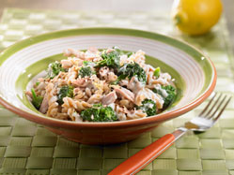
This is truly a one-pot dish – the pasta cooks in the milk and creates the sauce. With all four foods groups in one simple dish, you’re set for dinner.

Ingredients:
- 2 ¾ cups (675ml) 1% milk, divided
- 1 ¾ cup (425ml) water
- 10oz (300g) whole wheat rotini or fusilli pasta
- 6 cups (1.5L) chopped broccoli florets (1 large bunch)
- 8oZ (250g) ricotta cheese
- 1 tsp. (5ml) grated lemon zest
- 3 Tbsp. (45ml) freshly squeezed lemon juice
- ¼ tsp. (1ml) pepper
- 2 cans (340g) water-packed flaked tuna, drained
Directions:
- Add 2 ½ cups (625ml) of milk and water to a large pot.
- Cook over medium heat until steaming.
- Stir in pasta.
- Cover pot and reduce heat to medium-low.
- Boil for 10 minutes, stirring once.
- Add broccoli on top of pasta.
- Cover and boil for 5 minutes. Pasta will be tender. Broccoli will be tender but still crisp.
- Stir in ricotta, lemon zest, lemon juice, and pepper into pot. Mix well.
- Add some milk if sauce is too thick.
- Gently stir in tuna.
- Remove from heat when pasta is heated through.
- Serve.

