Roasted Chickpeas:
(Sweet cinnamon chickpeas)
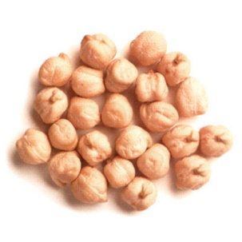 | Chickpeas
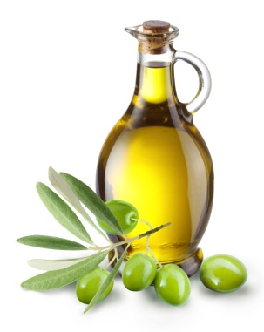 | Olive oil
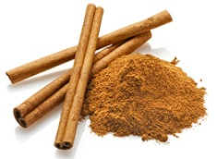 | Cinnamon
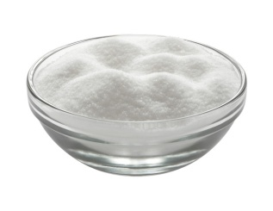 | Sugar

(Savory pizza crunch chickpeas)

 | Chickpeas
 | Olive oil
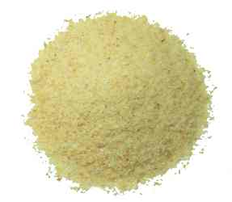 | Parmesan cheese
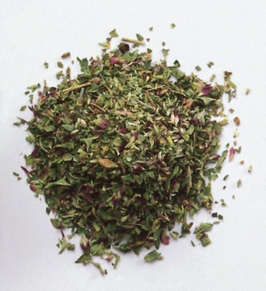 | Dried oregano
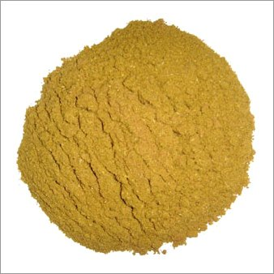 | Garlic powder

(Southwestern spice chickpeas)
 | Chickpeas
 | Olive oil
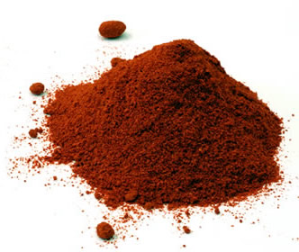 | Chili powder
 | Cumin
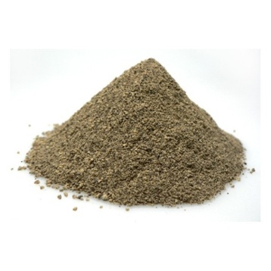 | Black pepper
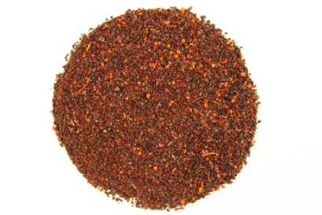 | Cayenne pepper

