Turkey tortilla wrap
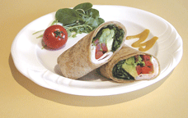
Makes 1 serving
Quick fix tip: Tortilla wrap are good for school lunches. They are easy to make the night before.
You can wrap it in plastic wrap and refrigerate
Ingredients
- 1 soft whole-wheat tortilla
- 2 tsp (10 mL) honey mustard
- 3 leaves of dark spinach
- 1/2 fresh sweet green, red, or yellow pepper, thinly sliced
- 1/4 small, ripe avocado, pit and skin removed, thinly sliced
- Cooked turkey.
Directions
- Place the tortilla on a plate and spread the honey mustard on tortilla.
- Place spinach, pepper, avocado, and turkey in rows down the center of the tortilla.
- Fold the edges over the filling, then roll up tightly. Cut in half.

